# **Task 3:**

Detect the peak in ECG signal using Haar wavelet transform and also identify some basic cardiac disorders.

# **Theory:**

If R-R interval = 0.5 then it is normal.

If R-R interval < 0.5 then it is classified as Bradycardia.

If R-R interval > 0.5 then it is classified as Tachycardia.

# **Code:**

clc

close all

ecgsig = load('ecgsig.txt');

tm = linspace(0,27.7750,10000);

figure(1)

plot(tm,ecgsig)

title('Original noise free ECG signal');

hold on

pk = findpeaks(ecgsig,tm);

plot(tm,pk,'ro')

xlabel('Time in Seconds'); ylabel('Amplitude');

wt = modwt(ecgsig,5);

wtrec = zeros(size(wt));

wtrec(4:5,:) = wt(4:5,:);

y = imodwt(wtrec,'haar');

[a,b] = wavedec(y,6,'haar');

[a1,b1,c1,d1,e1,f1] = detcoef(a,b,[1 2 3 4 5 6]);

figure(2)

plot(tm,y)

hold on

y = abs(y).^2;

[qrspeaks,locs] = findpeaks(y,tm,'MinPeakHeight',0.1);

plot(locs,qrspeaks,'go')

xlabel('Seconds'); ylabel('Amplitude');

title('R Peaks Localized by Harr Wavelet Transform')

%Signal decomposition using Harr Wavelet Transform

figure(3)

subplot(3,2,1)

plot(a1)

subplot(3,2,2)

plot(b1)

subplot(3,2,3)

plot(c1)

subplot(3,2,4)

plot(d1)

subplot(3,2,5)

plot(e1)

subplot(3,2,6)

plot(f1)

%average R-R interval

rr = mean(diff(locs));

# **Output:**





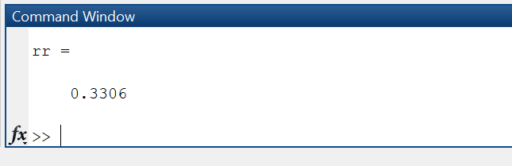

# **Conclusion:**

**Since the R-R interval calculated is less than 0.5, the following ECG signal is of a Bradycardia patient.**